Liam Gowan B00673126

CSCI 1100 – Summer 2015
Assignment 2 – Due May 27th (11:00pm – night time)
Submit on Moodle

Assignments are to be your own work. If you have questions, you can ask your Instructor, course TAs or TAs in the learning centre.

Declaration: Please complete this declaration
1 | “This document is entirely my own work.” | Yes/no
2 | I obtained help to complete this document. | Yes/no. If Yes, give Details.
3 | This document contains some material copied or cut and pasted from the internet or another document or file or program. | Yes/no. If Yes, give details and provide references.

Your task is to complete this report using Word and JGrasp and to submit the complete word document on Moodle. Acknowledge any help that you obtained from the Course or Learning Centre TAs in the table above.

Submit using Moodle. Make sure you double check that the file has been added to Moodle.
TAs can only provide help understanding the problem and other small hints.

Make sure you provide the programming code neatly formatted and properly commented (you will lose marks for poor formatting and commenting).

Also, provide test outputs that shows both/all conditions.

Exercise 1. Write a program that asks a person their weight in kilograms and their height in meters. Then the program calculates their BMI (Body Mass Index). The calculation is: weight (kg) / height (m)². If their BMI is <18.5 then tell the user their BMI score, that it is low and that they should consider gaining weight. If their BMI is 18.5-24.9 then tell the user their BMI score and that their BMI is normal. If their BMI is >=25 then tell the user their BMI score, that is high and that they should consider losing weight. Don’t worry about controlling the decimal point.

Printout of Properly Formatted Source Code

import java.util.Scanner; //imports Scanner class
public class BMI{
public static void main(String[] args){
double weight, height, BMI; //declares double variables
Scanner input = new Scanner(System.in); //declares Scanner variable
/*The following prompts user for weight and height, and
assigns values to respective variables
*/
System.out.print("Enter your weight in kilograms: ");
weight = input.nextDouble();
System.out.print("Enter your height in metres: ");
height = input.nextDouble();
BMI = weight / Math.pow(height, 2); //calculates BMI
System.out.print("\nYour BMI is " + BMI+"."); //Displays BMI
/*The following determines if BMI is less than 18.5, between 18.5 and 24.9,
or greater than or equal to 25. Based on the BMI, the program
tells user what they should do.
*/
if(BMI < 18.5)
System.out.print(" This is low. You should consider gaining weight.");
else if(BMI >= 18.5 && BMI <= 24.9)
System.out.print(" This is normal. Keep on going with your healthy lifestyle.");
else if(BMI >= 25)
System.out.print(" This is high. You should consider losing weight");
}
}

Example output/test cases (3 test cases – show one of each outcome different than above).

Test 1.
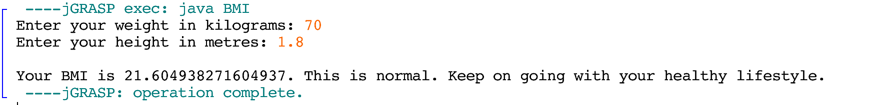
Test 2.
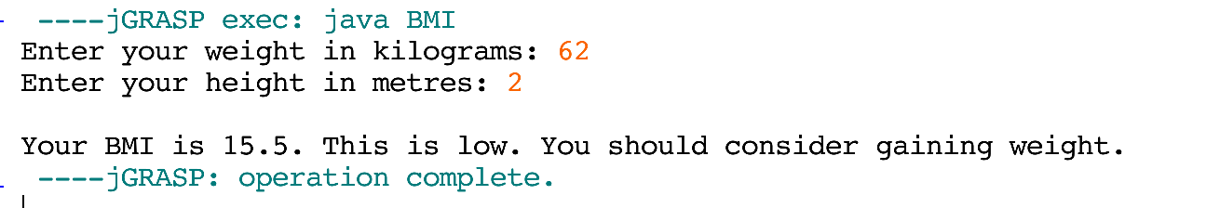
Test 3.
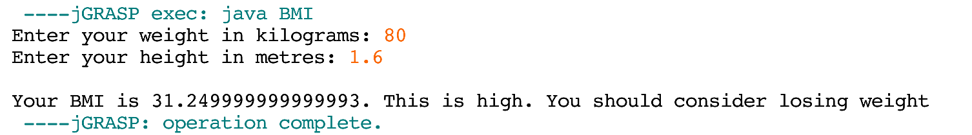

Exercise 2. Write a program that asks a user to enter in four integers and prints “Two Pairs” if the inputs consist of two matching pairs (in any order) or “Not Two Pairs” otherwise. Use the and (&&) and or (||) operators.

Sample output:
Input four numbers: 2 2 2 2
2 2 2 2 Two Pairs
Input four numbers: 1 2 2 1
1 2 2 1 Two Pairs
Input four numbers: 1 2 3 2
1 2 3 2 Not Two Pairs
Input four numbers: 1 2 1 2
1 2 1 2 Two Pairs
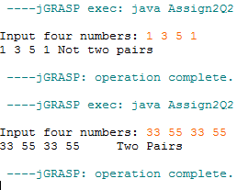

Printout of Properly Formatted Source Code

import java.util.Scanner; //imports Scanner class
public class Pairs{
public static void main(String[] args){
int num1, num2, num3, num4; //declares int variables
Scanner input = new Scanner(System.in); //declares Scanner variable
System.out.print("Input four numbers: "); //prompts user for four numbers
num1 = input.nextInt(); //assigns number to num1
num2 = input.nextInt(); //assigns number to num2
num3 = input.nextInt(); //assigns number to num3
num4 = input.nextInt(); //assigns number to num4
System.out.print(num1 + " " +num2 + " "+ num3 + " " + num4); //Prints #’s
//The following statements test for pairs in the four numbers
/*If num1 is the same as num2 AND num1 is the same as num3 OR num1 is the
same as num4 OR num2 is the same as num3 OR if num2 is the same as num4
OR if num3 is the same as num4, the program will print "Two Pairs".
*/
if((num1 == num2) && (num1 == num3 || num1 == num4||
num2 == num3 || num2 == num4 || num3 == num4))
System.out.print("\t\tTwo Pairs");
/*If num1 is the same as num3 AND num1 is the same as num2 OR num1 is the
same as num4 OR num2 is the same as num3 OR if num2 is the same as num4
OR if num3 is the same as num4, the program will print "Two Pairs".
*/
else if((num1 == num3) && (num1 == num2 || num1 == num4||
num2 == num3 || num2 == num4 || num3 == num4))
System.out.print("\t\tTwo Pairs");
/*If num1 is the same as num4 AND num1 is the same as num3 OR num1 is the
same as num2 OR num2 is the same as num3 OR if num2 is the same as num4
OR if num3 is the same as num4, the program will print "Two Pairs".
*/
else if((num1 == num4) && (num1 == num2 || num1 == num3||
num2 == num3 || num2 == num4 || num3 == num4))
System.out.print("\t\tTwo Pairs");
/*If num2 is the same as num3 AND num1 is the same as num3 OR num1 is the
same as num4 OR num1 is the same as num2 OR if num2 is the same as num4
OR if num3 is the same as num4, the program will print "Two Pairs".
*/
else if((num2 == num3) && (num1 == num2 || num1 == num4||
num1 == num3 || num2 == num4 || num3 == num4))
System.out.print("\t\tTwo Pairs");
/*If num2 is the same as num4 AND num1 is the same as num3 OR num1 is the
same as num4 OR num2 is the same as num3 OR if num1 is the same as num3
OR if num3 is the same as num4, the program will print "Two Pairs".
*/
else if((num2 == num4) && (num1 == num2 || num1 == num4||
num2 == num3 || num1 == num3 || num3 == num4))
System.out.print("\t\tTwo Pairs");
/*If num3 is the same as num4 AND num1 is the same as num3 OR num1 is the
same as num4 OR num2 is the same as num3 OR if num2 is the same as num4
OR if num1 is the same as num3, the program will print "Two Pairs".
*/
else if((num3 == num4) && (num1 == num2 || num1 == num4||
num2 == num3 || num2 == num4 || num1 == num3))
System.out.print("\t\tTwo Pairs");
//If none of the conditions are true, print "Not Two Pairs"
else
System.out.print("\t\tNot Two Pairs");
}
}

Example output/test cases (4 test cases – they should be different than the samples).

Test 1.

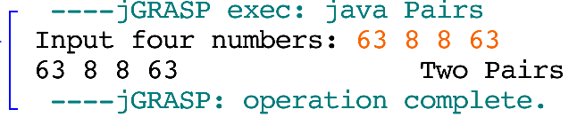

Test 2.

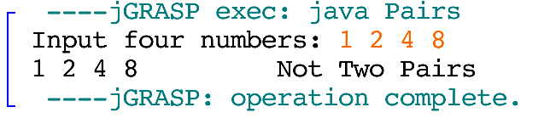

Test 3.

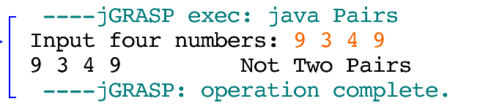

Test 4.

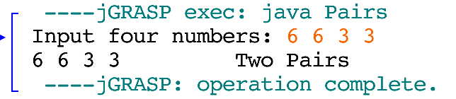

Exercise 3. Write a program that provides course advise for students. Ask a student to enter in whether they are a new student or a second year student. Then ask the user if their major is Computer Science or Psychology. If a student is a new student and their major is Computer Science, they must take CSCI 1100 and CSCI 1101 in their first year. If a student is a new student and their major is Psychology they must take PSYO 1011 and PSYO 1021 in their first year. If a student has finished their first year and their major is Computer Science they must take CSCI 2110 in their second year. If a student has finished their first year and their major is Psychology, they must take PSYO 2000 in their second year. Use the and(&&) and or(||) operators.
Printout of Properly Formatted Source Code

import java.util.Scanner;//imports scanner class
public class CourseAdvisor{
public static void main(String[] args){
int year, major; //declares int variables
Scanner input = new Scanner(System.in); //declares scanner variable
//prompts user for year, and assigns value to year
System.out.print("Enter 1 if you are a new student. " +
"Enter 2 if you are a second year student: ");
year = input.nextInt();
//prompts user for major and assigns value to major
System.out.print("\nEnter 1 if your major is Computer Science. " +
"Enter 2 if your major is Psychology: ");
major = input.nextInt();
if(year == 1 && major == 1){
//will print if user is in first year computer science
System.out.print("\nYou need to take CSCI 1100 and CSCI 1101 " +
"in your first year.");
}
else if(year == 1 && major == 2){
//will print if user in first year psychology
System.out.print("\nYou need to take PSYO 1011 and PYSO 1021 " +
"in your first year.");
}
else if(year == 2 && major == 1){
//will print if user is in second year computer science
System.out.print("\nYou need to take CSCI 2110 " +
"in your second year.");
}
else if(year == 2 && major ==2){
//will print if user in second year psychology
System.out.print("\nYou need to take PSYO 2000 " +
"in your second year.");
}
}
}

Example output/test cases (4 test cases – show one of each outcome).

Test 1.

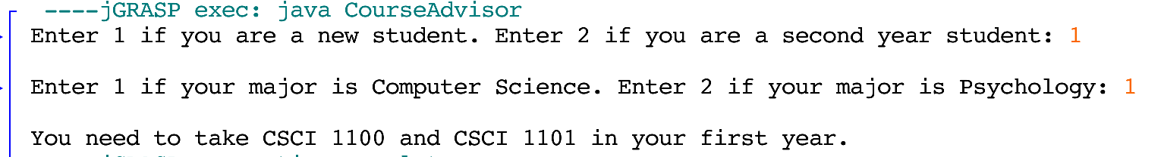

Test 2.

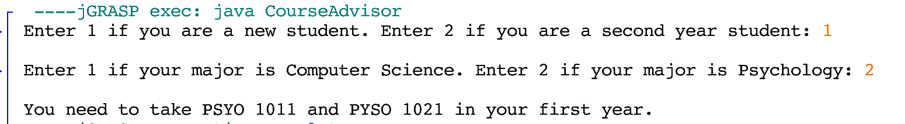

Test 3.

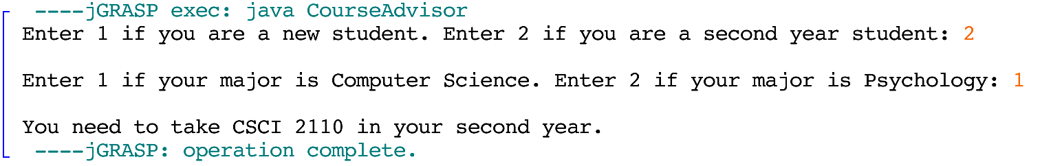

Test 4.

